

**CSE488: Big Data Analytics**

**[SPRING 2023]**

**All Online Lab**

**MapReduce program**

**Submitted by:**

Student ID: 2019-3-60-046

Student Name: Mohsenul Kabir Mithun

**LAB 1**

**--------------------------------------------**

**1. Find the Aircraft, country flying mission and target country for those missions in which time on target was less than 1000.**

Bombing_Operations.createOrReplaceTempView('bombing_operation')

query = """

SELECT AirCraft, ContryFlyingMission, TargetCountry

FROM bombing_operation

WHERE TimeOnTarget < 1000

"""

result = spark.sql(query)

result.show()

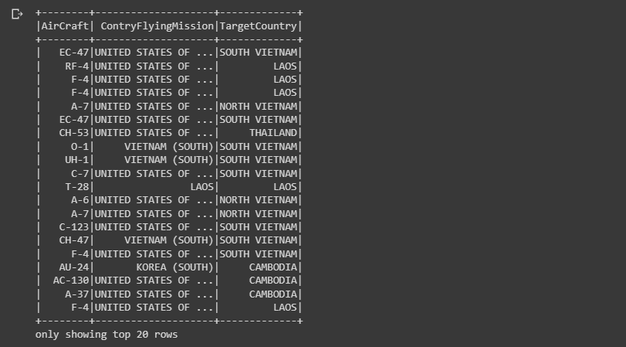

**2. Find the target country and the number of times they have been attacked. Show the**

**result in descending order.**

Bombing_Operations.createOrReplaceTempView('bombing_operation')

query = """

SELECT TargetCountry, COUNT(TargetCountry) AS Attack

FROM bombing_operation

GROUP BY TargetCountry

ORDER BY COUNT(TargetCountry) DESC

"""

result = spark.sql(query)

result.show()

**3. Find the target country which had been attacked most.**

Bombing_Operations.createOrReplaceTempView('bombing_operation')

query1 = """

SELECT TargetCountry, COUNT(TargetCountry) AS NoOfAttack

FROM bombing_operation

GROUP BY TargetCountry

ORDER BY COUNT(TargetCountry) DESC

"""

result = spark.sql(query1)

result.createOrReplaceTempView('TempResult')

query2 = """

SELECT *

FROM TempResult

WHERE NoOfAttack = (SELECT MAX(NoOfAttack)

FROM TempResult)

"""

result = spark.sql(query2)

result.show()

**4. Find the country flying mission which attacked most.**

Bombing_Operations.createOrReplaceTempView('bombing_operation')

query1 = """

SELECT ContryFlyingMission, COUNT(ContryFlyingMission) AS NoOfFlyingMission

FROM bombing_operation

GROUP BY ContryFlyingMission

ORDER BY COUNT(ContryFlyingMission) DESC

"""

result = spark.sql(query1)

result.createOrReplaceTempView('TempResult')

query2 = """

SELECT *

FROM TempResult

WHERE NoOfFlyingMission = (SELECT MAX(NoOfFlyingMission)

FROM TempResult)

"""

result = spark.sql(query2)

result.show()

**5. Find the take-off location and how many times they had used.**

Bombing_Operations.createOrReplaceTempView('bombing_operation')

query = """

SELECT TakeoffLocation, COUNT(TakeoffLocation) AS NoOfTakeoffLocation

FROM bombing_operation

GROUP BY TakeoffLocation

"""

result = spark.sql(query)

result.show()

**6. Find the number of fighter jets from Aircraft_Glossary.**

Aircraft_Glossary.createOrReplaceTempView('aircraft_glossary')

query = """

SELECT COUNT(AirCraftType) as TotalNoOfFighterJet

FROM aircraft_glossary

WHERE AirCraftType == 'Fighter Jet'

"""

result = spark.sql(query)

result.show()

**7. Find the number of different types aircraft for each air craft type.**

Aircraft_Glossary.createOrReplaceTempView('aircraft_glossary')

query = """

SELECT AirCraftType, COUNT(AirCraftType) AS NoOfAirCraftType

FROM aircraft_glossary

GROUP BY AirCraftType

"""

result = spark.sql(query)

result.show()

**8. Find the aircraft name which had used most in attacks.**

Aircraft_Glossary.createOrReplaceTempView('aircraft_glossary')

Bombing_Operations.createOrReplaceTempView('bombing_operation')

query1= """

SELECT AirCraftName, TargetCountry

FROM aircraft_glossary A, bombing_operation B

WHERE A.AirCraft = B.AirCraft

"""

result = spark.sql(query1)

result.createOrReplaceTempView("TempResult1")

query2 = """

SELECT AirCraftName, COUNT(AirCraftName) as NoOfAirCraftName

FROM TempResult1

GROUP BY AirCraftName

"""

result = spark.sql(query2)

result.createOrReplaceTempView("TempResult2")

query3 = """

SELECT *

FROM TempResult2

WHERE NoOfAirCraftName == (SELECT MAX(NoOfAirCraftName)

FROM TempResult2 )

"""

result = spark.sql(query3)

result.show()

**LAB 3**

**--------------------------------------------**

**Creating a Hadoop project in Eclipse: (MapReduce used for SumCalculator)**

**🡪 MapReduce Program for SumCalculator:**

1. Open Eclipse IDE

2. Copy 'training' project and paste it on same place by name it "SumCalculator "

3. Expand SumCalculator 🡪 src 🡪 (default package)

4. Rename 4 of 3 java files are " SumCalculator.java", " SumReducer.java", " SumMapper.java" and replace the code that I provide bellow,

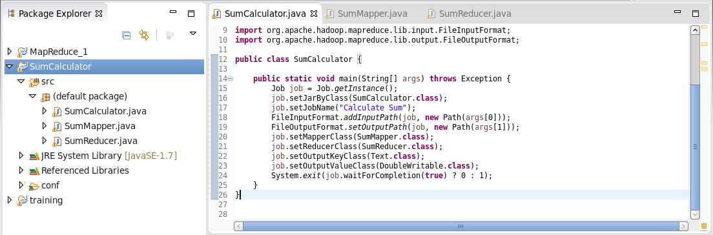

5. Right click on ' SumCalculator ' project 🡪  export 🡪 java 🡪 select jar 🡪 Next 🡪 give a jar file name as "Sum.jar" 🡪 Next 🡪 Next 🡪 Finish

6. Avoid if any error message occurs.

7. Go to http://quickstart.cloudera:8888/accounts/login/?next=/

8. Login by using Username: cloudera & Password: cloudera

9. Go to file browser that you see upper right side of the browser

10. Create new directory by click on New 🡪 Directory 🡪 provide name as ‘sum’ 🡪 go that directory create new file as file1.csv

11. Go to that file1.csv 🡪 click on 'edit file' option and add some text as coma separated. Then save it.

12. open CMD and write bellow command

hadoop jar sum.jar SumCalculator  /user/cloudera/sum/file1.txt  sumout

More generic way to explain:

🡪 hadoop jar <jar file> <main class> <input path> <output path>

13. To see output go to ‘Web Browser’ where you create a folder and add csv file. Here you also see another folder named "sumout" In this folder you will find the output.

**LAB 4**

**--------------------------------------------**

**Creating a Hadoop project in Eclipse: (MapReduce used for finding Employee)**

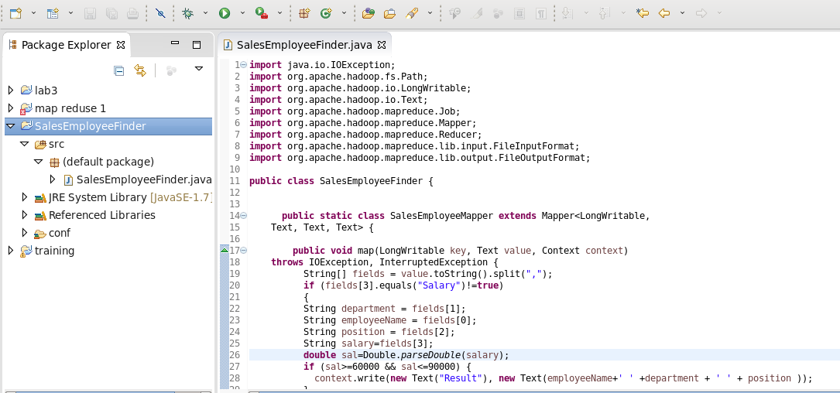

Input:

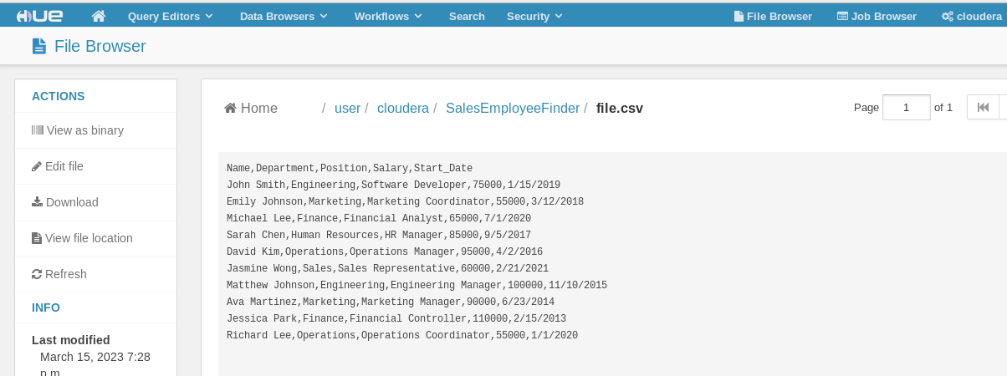

Jar Creation:

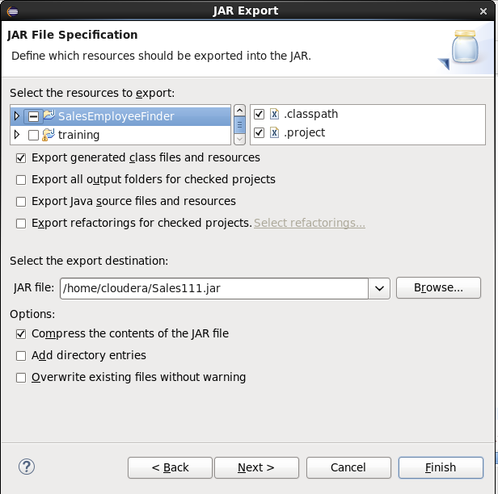

CMD run the program:

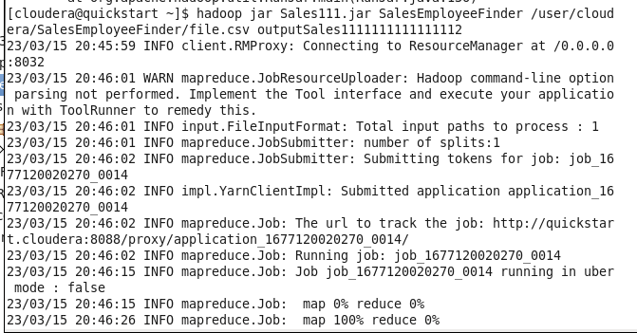

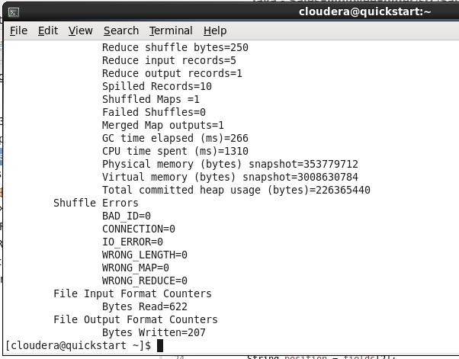

Output:

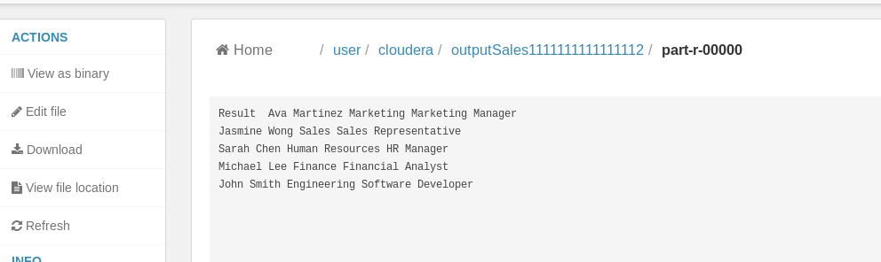

**LAB 5**

**--------------------------------------------**

**Creating a Hadoop project in Eclipse: (MapReduce used for ItemsetCount)**

Source Code SS: (Mapper and Reducer Class)

Creating Jar file:

Creating Input file:

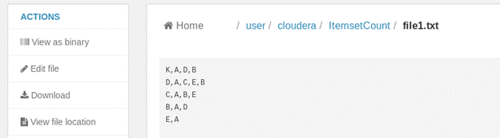

CMD run the program:

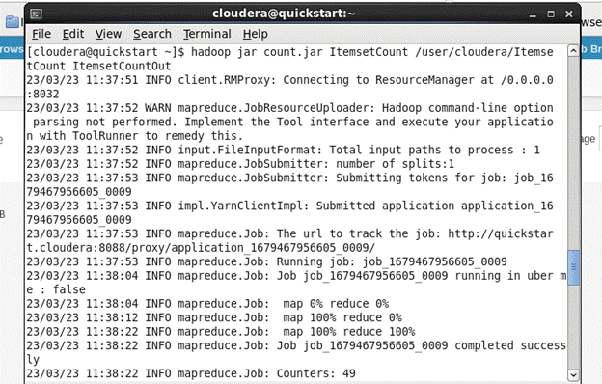

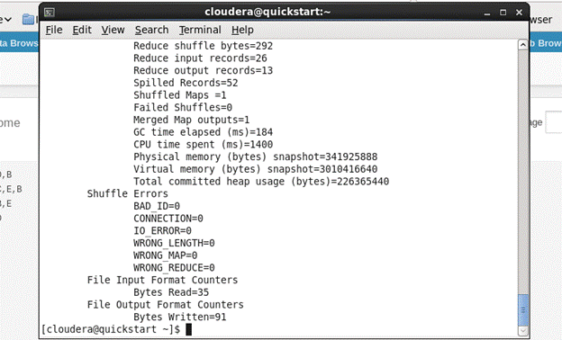

Output:

**LAB 6**

**--------------------------------------------**

**Creating a Hadoop project in Eclipse:**

**1.  Find the occurrences of each page (numbered as 1, 2, 3, and so on).**

Source Code SS: (Mapper and Reducer Class)

Creating Jar file:

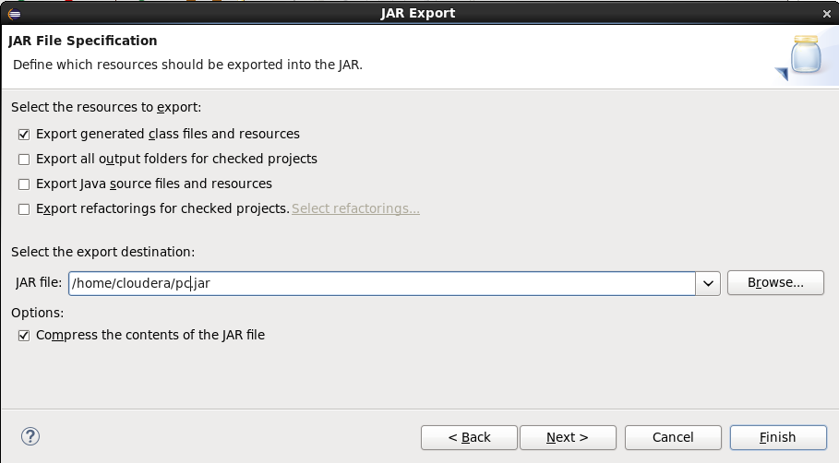

Creating Input file:

CMD run the program:

Output:

**2.** **Find the most visited page. You may use the output file generated from Question 1 as an input file to solve this problem.**

Source Code SS: (Mapper and Reducer Class)

Creating Jar file:

Creating Input file:

CMD run the program:

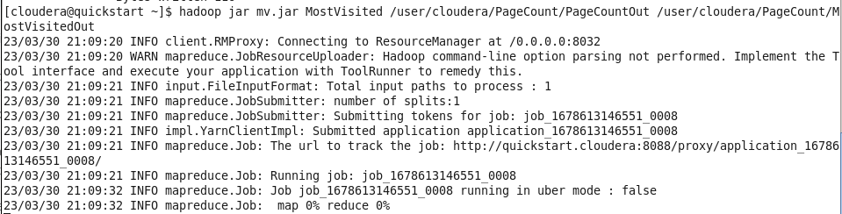

Output:

**3.** **Find the least visited page. You may use the output file generated from Question 1 as an input file to solve this problem.**

Source Code SS: (Mapper and Reducer Class)

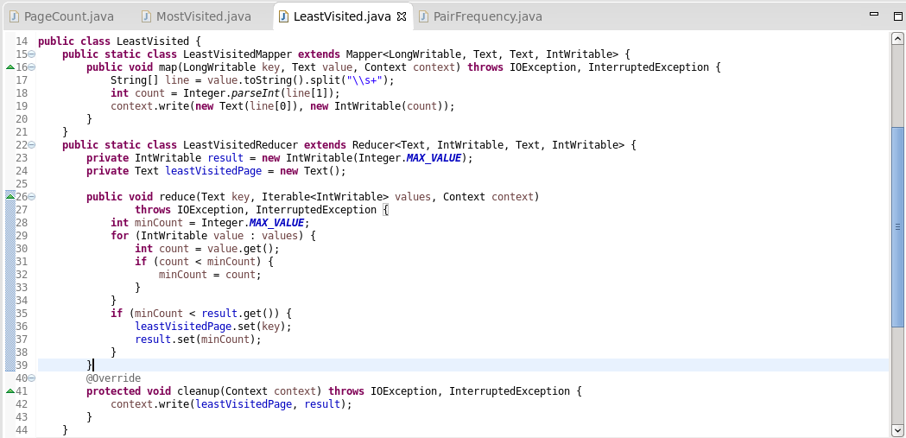

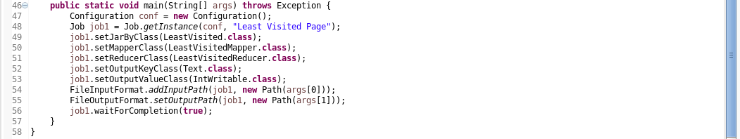

Creating Jar file:

Creating Input file:

CMD run the program:

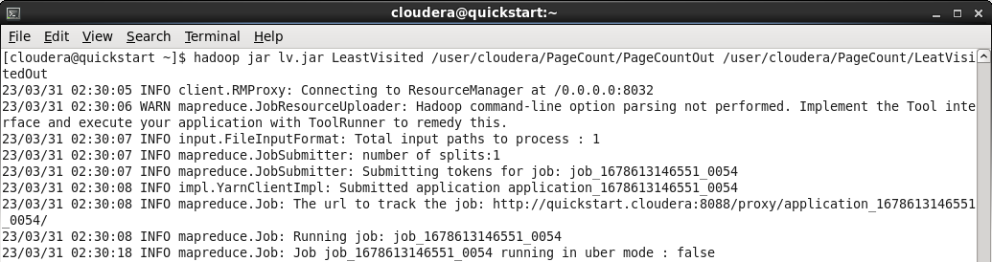

Output:

**4.** **Find the frequency of pairs. In this case, remove the duplicate numbers from each transaction as a data pre-processing step. Use the concept of Java set for removing duplicates.**

Source Code SS: (Mapper and Reducer Class)

Creating Jar file:

Creating Input file:

CMD run the program:

Output:

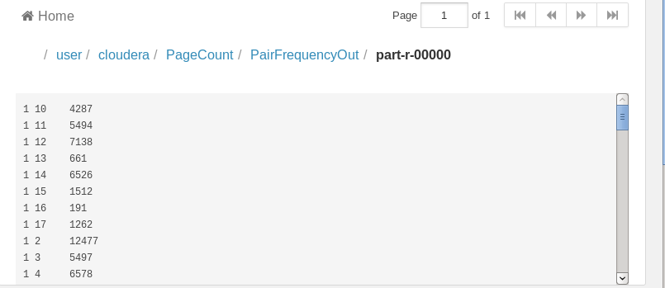

**LAB 3 Bonus Part**

**--------------------------------------------**

**1. Bonus: If you are able to execute this program, then write a program of your own that generates sum of Odd and sum of even numbers from the same csv files.**

Source Code SS: (Mapper and Reducer Class)

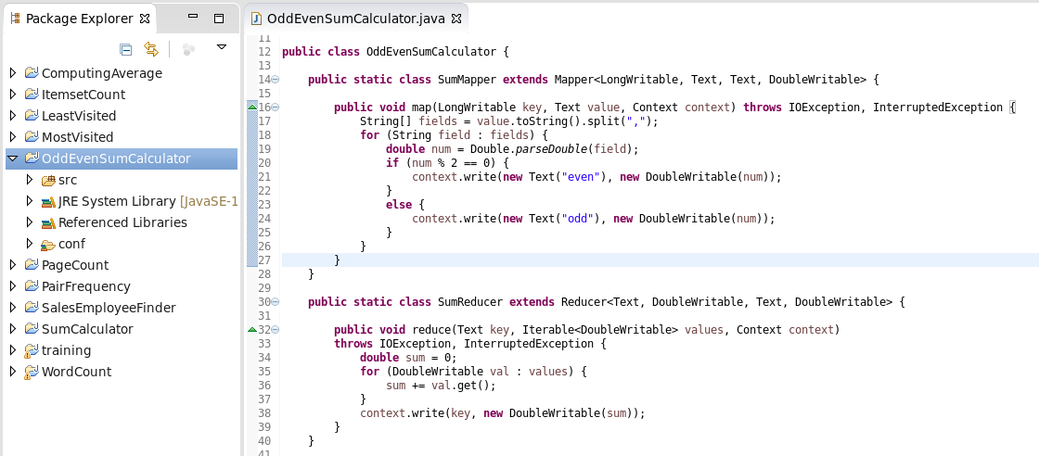 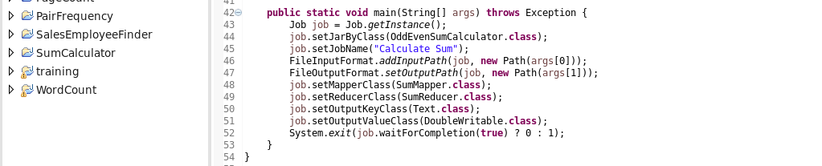

Creating Input file:

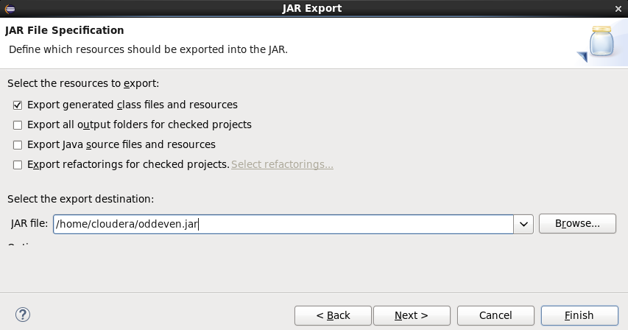

Creating Input file:



CMD run the program:

Output:

